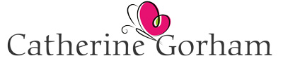

Leading from Within: A Leadership Development Circle

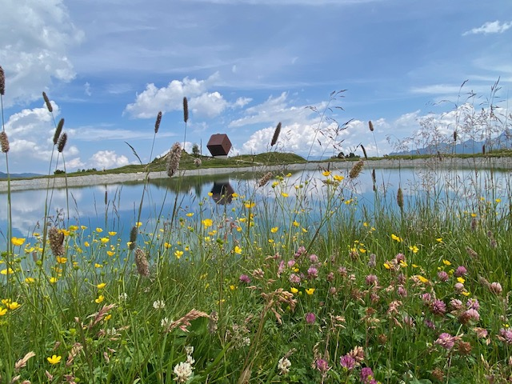

Designed for:
Leaders struggling with self-confidence and trusting own instinct/abilities as a leader; hesitant to speak up or be visible in their own authority; concerned what others think which may lead to perfectionist, apologetic tendencies. Those who may benefit from the healing effect of being seen, heard and celebrated in a closed, relatively safe, development group over an extended period of time.
Process:
This will be a co-created confidential space where individuals are encouraged to bring themselves; over time this may include those parts of self which they feel less comfortable to show to others, but all activities will be carefully contracted around and no one will be asked to do something beyond their safety threshold. Safety in the group will be continuously reviewed as part of the calibration of personal boundaries.
It will be a development circle, not a therapy group although some deep-rooted patterns may be worked with. (If at any point an individual’s early trauma is activated, this will be supported outside of the group and may include signposting to therapy.)
Ahead of each session, participants will be invited to prepare with some creative prompts.
Each session will build on the last, with the process deepening trust and group intimacy over time. This will be achieved through:
*co-creating conditions to enable some psychological safety in the circle.
*building a sense of belonging in the circle through intentional practices of being seen and heard.
*offering creative tools for developing a greater sense of self.
*creating opportunities for celebrating each other.
The circle will be facilitated with gentleness, kindness, compassion and careful boundary management.
Objectives:
Participants will be supported to
*build a practice of kindness and compassion for self
*develop greater self-confidence
*deepen their personal and professional identity
*listen to and trust their own instinct more
*soften their own high expectations of themselves and others
*build their own sense of worth, even if the organisation has limited capacity to appreciate their value
*practise connecting with and expressing their own needs
*develop their unique authentic leadership brand.
Practicalities:
This will be a closed group, meeting monthly online 6 times for 1.5 hrs per session. Maximum number of participants is 6 leaders, commencing Autumn 2026 with dates to be agreed.
Fee:
This will be £950 for the programme of 6 sessions, payable up front.
About me:
I am an independent EMCC Accredited Coach (Senior Practitioner)/Accredited Supervisor and a Fellow of the Association for Coaching. I have a diverse supervision practice and am a certified Practitioner in the Psychological Safety Index tool. I am the Lead Supervisor for Sanctus, supporting a community of 25+ coaches to bring their best to wellbeing and leadership coaching to employees across an international portfolio of client organisations.
With training in ecotherapy, I specialise in Nature as Dynamic Co-partner which enables me to bring creativity into online group spaces. I am fascinated by groups and have completed the Foundation year in Group Analysis, through the Institute of Group Analysis. I am currently studying with the New York Center for Modern Psychoanalytic Studies.

catherinegorham.co.uk
catherine@catherinegorham.co.uk

